Git Workflow - Staging

From Workspace to staging
# Source: AI Source: Provided by: [Data Path: Persons Table -> ID Column: 1, Name_En Column: Motasem Essam] -> From: [Chatgpt (GPT‑5 Mini)] on [2/19/2026]
It sounds like you want to move changes from your local workspace (working directory) to the staging area in GitHub (really in Git, since GitHub is remote). Let’s break it down clearly:

Check your current workspace status
# Source: AI Source: Provided by: [Data Path: Persons Table -> ID Column: 1, Name_En Column: Motasem Essam] -> From: [Chatgpt (GPT‑5 Mini)] on [2/19/2026]
In your terminal:
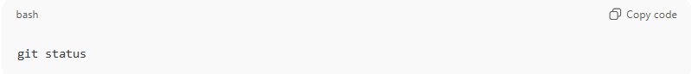
git status
This shows:
- Modified files that are not yet staged
- Untracked files
- Current branch

Stage changes
# Source: AI Source: Provided by: [Data Path: Persons Table -> ID Column: 1, Name_En Column: Motasem Essam] -> From: [Chatgpt (GPT‑5 Mini)] on [2/19/2026]
To move changes from your workspace to staging, you use:
a) Stage specific files:
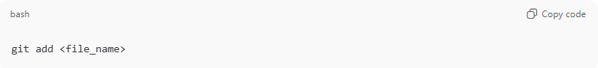
git add <file_name>
Example:
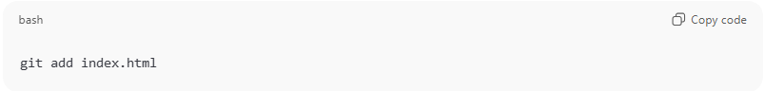
git add index.html
b) Stage all changes at once:
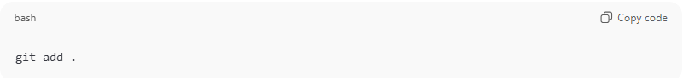
git add .
This adds all modified and new files to the staging area.

Verify staging area
# Source: AI Source: Provided by: [Data Path: Persons Table -> ID Column: 1, Name_En Column: Motasem Essam] -> From: [Chatgpt (GPT‑5 Mini)] on [2/19/2026]
After staging, you can check:
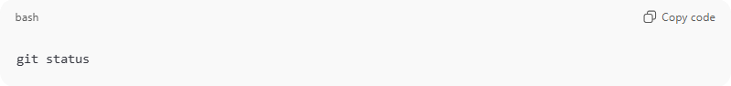
git status
You should see the files under “Changes to be committed”. That means they are now staged.

Moving files in Staging Area
# Source: AI Source: Provided by: [Data Path: Persons Table -> ID Column: 1, Name_En Column: Motasem Essam] -> From: [Chatgpt (GPT‑5 Mini)] on [2/19/2026]
Moving files (git mv)
- If you rename or move a file, Git needs to track it.
- git mv is a shortcut that does both the file move and stages it at the same time.
Example:
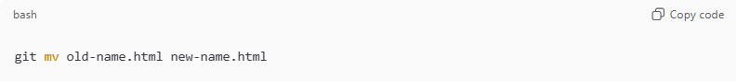
git mv old-name.html new-name.html
- This will:
  - Rename the file in your working directory.
  - Stage the change for the next commit (so Git knows the file was moved/renamed).
Equivalent manually:
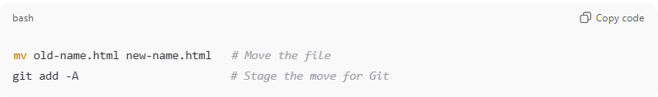
mv old-name.html new-name.html # Move the file
git add -A # Stage the move for Git

Removing files in Staging Area
# Source: AI Source: Provided by: [Data Path: Persons Table -> ID Column: 1, Name_En Column: Motasem Essam] -> From: [Chatgpt (GPT‑5 Mini)] on [2/19/2026]
Removing files (git rm)
- If you delete a file, Git doesn’t automatically know about it. You must stage the deletion.
Example:
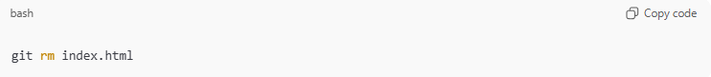
git rm index.html
- git rm deletes the file from the working directory and stages the deletion.
- If you already deleted the file manually, you can stage the deletion with:
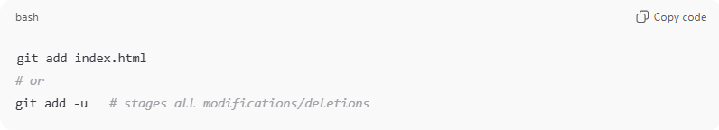
git add index.html
# or
git add -u # stages all modifications/deletions

💡 Tip:
After any move or deletion, you can always check what’s staged with:
git status
This is the easiest way to see if Git recognizes your file moves or deletions.

Example

Check your current workspace status
# Source: ScreenShots Source: Provided by: [Persons Table -> ID Column: 1, Name_En Column: Motasem Essam] -> Tool: [Lightshot Program] -> From [Windows] on [2/19/2026]
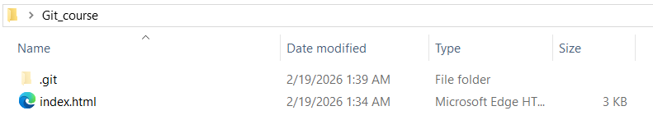
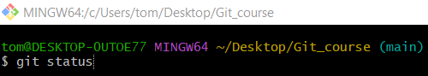
git status
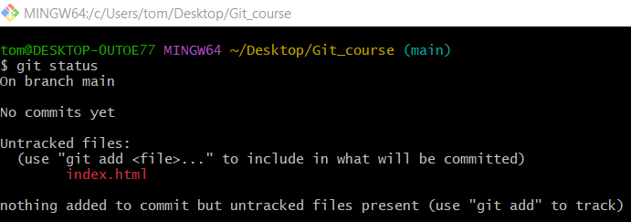

Stage changes
# Source: ScreenShots Source: Provided by: [Persons Table -> ID Column: 1, Name_En Column: Motasem Essam] -> Tool: [Lightshot Program] -> From [Windows] on [2/19/2026]
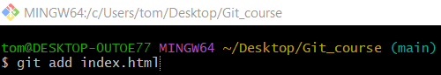
git add index.html

Verify staging area
# Source: ScreenShots Source: Provided by: [Persons Table -> ID Column: 1, Name_En Column: Motasem Essam] -> Tool: [Lightshot Program] -> From [Windows] on [2/19/2026]

git status
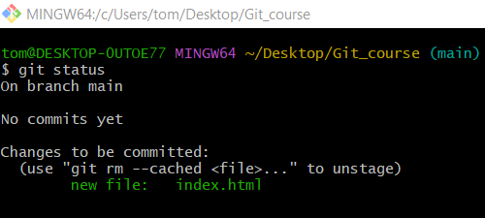

Moving files in Staging Area
# Source: ScreenShots Source: Provided by: [Persons Table -> ID Column: 1, Name_En Column: Motasem Essam] -> Tool: [Lightshot Program] -> From [Windows] on [2/19/2026]
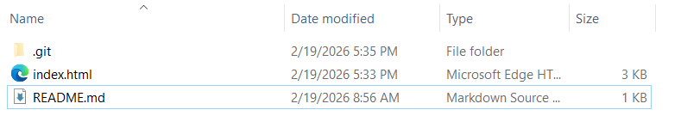
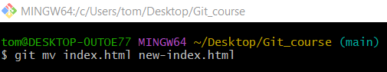
git mv index.html new-index.html
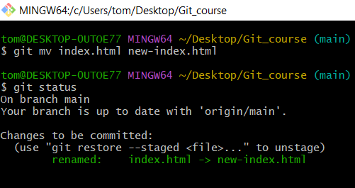

Removing files in Staging Area
# Source: ScreenShots Source: Provided by: [Persons Table -> ID Column: 1, Name_En Column: Motasem Essam] -> Tool: [Lightshot Program] -> From [Windows] on [2/19/2026]

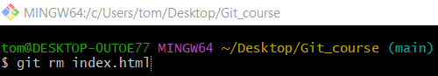
git rm index.html
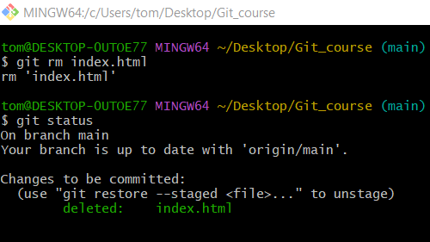

From staging to Workspace
# Source: AI Source: Provided by: [Data Path: Persons Table -> ID Column: 1, Name_En Column: Motasem Essam] -> From: [Chatgpt (GPT‑5 Mini)] on [2/19/2026]
Ah! You’re asking about going from staging back to the workspace — basically unstaging changes in Git. This is like saying, “Oops, I staged this, but I’m not ready to commit it yet.”
Here’s how to do it:

Check what’s staged
# Source: AI Source: Provided by: [Data Path: Persons Table -> ID Column: 1, Name_En Column: Motasem Essam] -> From: [Chatgpt (GPT‑5 Mini)] on [2/19/2026]
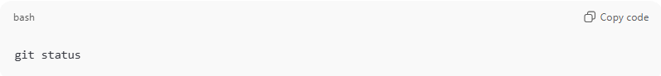
git status
You’ll see something like:
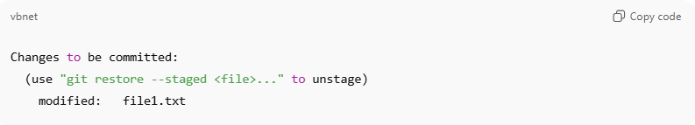
Changes to be committed:
(use "git restore --staged <file>..." to unstage)
modified: file1.txt
Files listed under “Changes to be committed” are staged.

Unstage a file (move from staging back to workspace)
# Source: AI Source: Provided by: [Data Path: Persons Table -> ID Column: 1, Name_En Column: Motasem Essam] -> From: [Chatgpt (GPT‑5 Mini)] on [2/19/2026]
a) Single file
If your repository already has at least one commit:
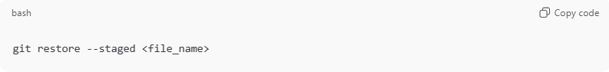
git restore --staged <file_name>
Example:
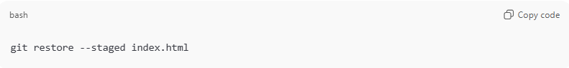
git restore --staged index.html

If your repository has no commits yet, use:
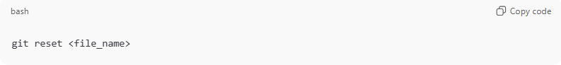
git reset <file_name>
Example:
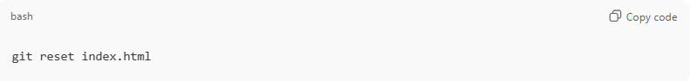
git reset index.html

b) All staged files
If your repository already has commits:
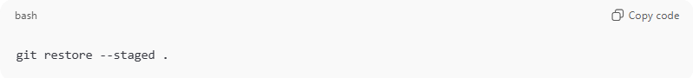
git restore --staged .
If your repository has no commits yet, use:
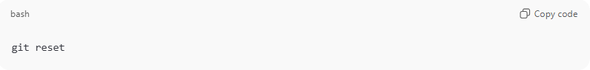
git reset
This unstages all files but keeps your changes in the working directory.

Verify
# Source: AI Source: Provided by: [Data Path: Persons Table -> ID Column: 1, Name_En Column: Motasem Essam] -> From: [Chatgpt (GPT‑5 Mini)] on [2/19/2026]
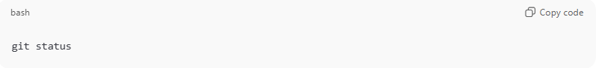
git status
Now the files should appear under “Changes not staged for commit” — meaning they’re back in your workspace but not staged.

⚡ Tip: In older Git versions, git reset HEAD <file> works the same way.

Example

Check what’s staged
# Source: ScreenShots Source: Provided by: [Persons Table -> ID Column: 1, Name_En Column: Motasem Essam] -> Tool: [Lightshot Program] -> From [Windows] on [2/19/2026]

git status


Unstage a file (move from staging back to workspace)
# Source: ScreenShots Source: Provided by: [Persons Table -> ID Column: 1, Name_En Column: Motasem Essam] -> Tool: [Lightshot Program] -> From [Windows] on [2/19/2026]
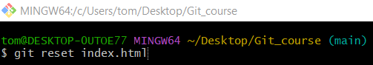
git reset index.html

Verify
# Source: ScreenShots Source: Provided by: [Persons Table -> ID Column: 1, Name_En Column: Motasem Essam] -> Tool: [Lightshot Program] -> From [Windows] on [2/19/2026]

git status
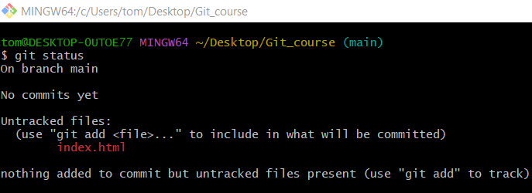

Differences between staged and unstaged changes
# Source: AI Source: Provided by: [Data Path: Persons Table -> ID Column: 1, Name_En Column: Motasem Essam] -> From: [Chatgpt (GPT‑5 Mini)] on [2/19/2026]
Let’s clarify the differences between staged and unstaged changes in Git, because this is a concept that often confuses beginners.

1️⃣ Unstaged Changes (Working Directory)
# Source: AI Source: Provided by: [Data Path: Persons Table -> ID Column: 1, Name_En Column: Motasem Essam] -> From: [Chatgpt (GPT‑5 Mini)] on [2/19/2026]
- These are the changes you’ve made to your files, but haven’t told Git you want to include them in the next commit.
- Git sees them as “in progress” but not ready to save permanently.
Command to see them:
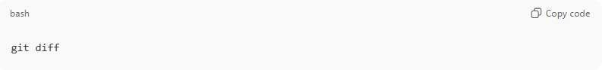
git diff
- This shows line-by-line changes in your files that are not yet staged.
- Example output snippet:
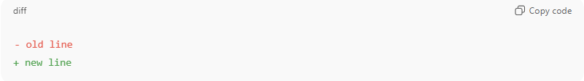
- old line
+ new line

2️⃣ Staged Changes (Staging Area / Index)
# Source: AI Source: Provided by: [Data Path: Persons Table -> ID Column: 1, Name_En Column: Motasem Essam] -> From: [Chatgpt (GPT‑5 Mini)] on [2/19/2026]
- Staged changes are the ones you’ve added with git add, meaning Git will include them in your next commit.
- You can think of staging as “preparing changes for commit.”
Command to see them:
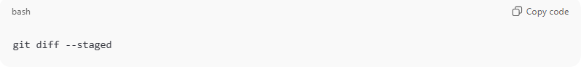
git diff --staged
or
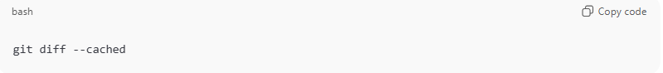
git diff --cached
- This shows the changes that are ready to be committed, compared to the last commit.

Workflow Visual
# Source: AI Source: Provided by: [Data Path: Persons Table -> ID Column: 1, Name_En Column: Motasem Essam] -> From: [Chatgpt (GPT‑5 Mini)] on [2/19/2026]
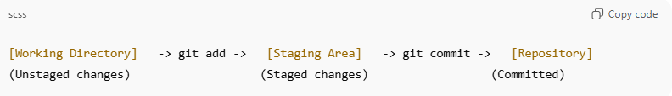
[Working Directory] -> git add -> [Staging Area] -> git commit -> [Repository]
(Unstaged changes) (Staged changes) (Committed)
- Edit files → changes are unstaged
- git add <file> → moves changes to staging area
- git commit → saves staged changes permanently in Git history

Quick Example
# Source: AI Source: Provided by: [Data Path: Persons Table -> ID Column: 1, Name_En Column: Motasem Essam] -> From: [Chatgpt (GPT‑5 Mini)] on [2/19/2026]
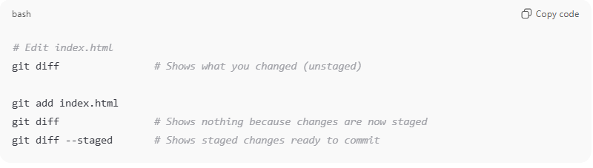
# Edit index.html
git diff # Shows what you changed (unstaged)

git add index.html
git diff # Shows nothing because changes are now staged
git diff --staged # Shows staged changes ready to commit

Optional navigation in the pager
# Source: AI Source: Provided by: [Data Path: Persons Table -> ID Column: 1, Name_En Column: Motasem Essam] -> From: [Chatgpt (GPT‑5 Mini)] on [2/19/2026]
While inside the less view, you can also:
- Space → go to the next page
- b → go back one page
- /text → search for “text”
- n → go to next search result
But usually, just pressing q is enough to exit.

💡 Key point:
# Source: AI Source: Provided by: [Data Path: Persons Table -> ID Column: 1, Name_En Column: Motasem Essam] -> From: [Chatgpt (GPT‑5 Mini)] on [2/19/2026]
- Unstaged: changes in your working files
- Staged: changes ready for commit

Example
# Source: ScreenShots Source: Provided by: [Persons Table -> ID Column: 1, Name_En Column: Motasem Essam] -> Tool: [Lightshot Program] -> From [Windows] on [2/19/2026]

git status

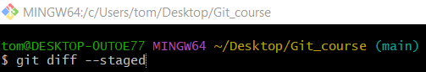
git diff --staged
